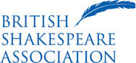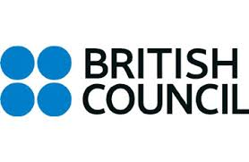
Teaching Shakespeare in Korea
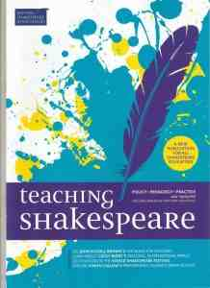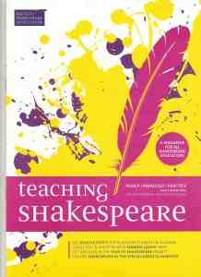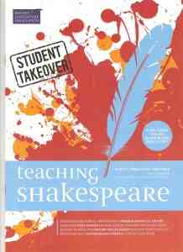
Thanks to the British Council, issue 9 of the British Shakespeare Association’s Teaching Shakespeare will focus on Korea.
We are seeking contributors who have:
- taught or studied Shakespeare in Korea – in schools, colleges, universities, language learning or arts organisations
- taught Korean students studying Shakespeare outside Korea
- studied Shakespeare outside Korea (and are usually Korean residents)
- been inspired by Korean productions, arts and culture etc. in teaching or staging Shakespeare anywhere…
Articles are short, 750-2000, words but we welcome a range of formats: interviews, vox pops, lesson plans, reviews and storyboards.
The editor, Dr Sarah Olive, University of York, is visiting Korea from 2-18 September. Although based in Seoul, she hopes to travel outside the capital to visit regional universities to give lectures/research seminars, co-teach classes, be part of question and answer sessions about her work on Shakespeare in popular culture and education, and talk to lecturers, students and theatre professionals. See https://york.academia.edu/SarahOlive or @DrSarahOlive
Please do get in touch with ideas or questions at sarah.olive@york.ac.uk with expressions of interest by 1st July 2015. It is envisaged that accepted articles would be submitted by 30th December 2015 and published in Spring 2016.
Past issues are freely available to read online or download at http://www.britishshakespeare.ws/education/teaching-shakespeare/

